University of Petroleum and Energy Studies
School of Computer Science
Department of Cybernetics

Graphics & Animation Tools
LAB FILE
(Session: 2020-2021)

Course: B.Tech with Specialization in Open Source and Open Standards

Submitted To- Submitted By-
Dr. Durgansh Sharma Rahul Raj Baranwal
Associate Professor SAP ID -500061624
Department of Cybernetics Roll No. -R100217054

Experiment-6 Design of 3D Hut using Blender
In this experiment we need to create a 3D Hut of our choice with the help of blender.
Steps to follow to create a 3D Hut using Blender
- Open Blender, and clear everything from the interface which are already there.
- Create a new file and go to mesh, and select cylinder and modify its properties, like vertices etc.
- If you want to measure the relative size of hut, create the model of human nearby it.
- Go to the front view, extend the boundary of cylinder and scale it a bit.
- Now for creating the entrance of the hut, go to mesh and select a cube and resize it and put it inside the boundary of your cylinder. After this change the view port display as wire.
- Adjust the edges and everything of the walls of your hut according to your choice.
- Now, go to upper view, and increase it upwards and mould it in the shape of cone (Or you can simply use a cone as a roof-top for your hut)
- Now, go to shading and then random and fill your selected area with random colours.
- Now, go to the top of your hut’s roof, and raise it a bit to give it a shape of spiked cone.
- Go to file and save it as your name and render a few pictures for the display.

Output Screen: (Rendered Images)
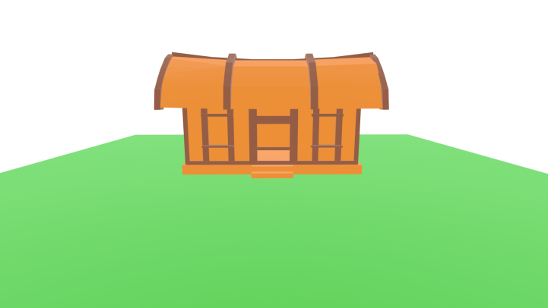

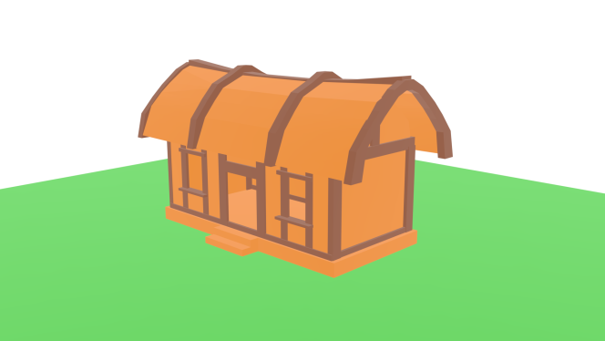

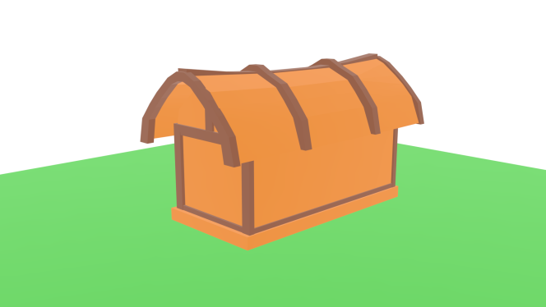
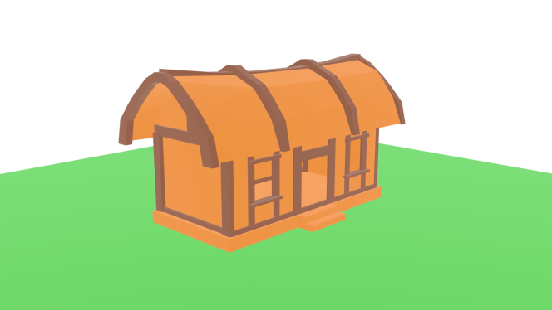

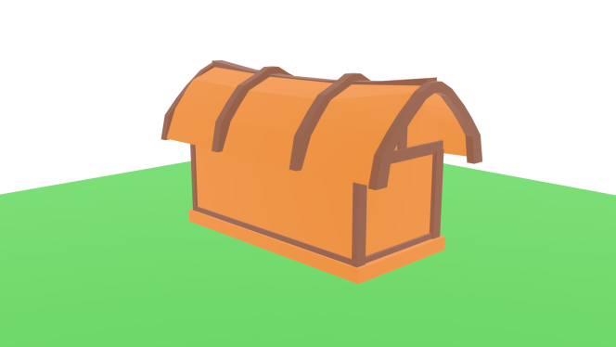

Link for the Experiment files:

